Débarras Aurea – Monitoring website leads in HubSpot
Test run on 23/09/2026 10:11 (Tunis time): a quote request sent through https://debarras-aurea.fr/api/leads with name “Walid Ghouili (TEST)” and message “TEST – ceci est un test…”. Result: contact, deal, note and API calls all succeeded.
Portal: Débarras Aurea (EU1, ID 149390256) – https://app-eu1.hubspot.com

What each website form creates
Form | Creates in HubSpot | Where to look
Devis (/devis, /lp/*, pro funnel) | Contact (new or updated) + Deal in “Nouveau lead” + Note with all details | Deals board, contact record
Contact (/contact) | Contact (new or updated) + Note | Contacts list, contact record

Contacts are matched by email first, then by phone, so a returning visitor updates the same contact instead of creating a duplicate.

1. Daily check – the Deals board (main view)
Deals → All deals → board view, pipeline “DÉBARRAS AUREA PIPELINE”. Every new quote request lands in the first column “Nouveau lead”, named “Devis – service – location – name”. Drag the card across the columns (À qualifier → Lead qualifié → Visite / estimation → Devis…) as the job progresses.
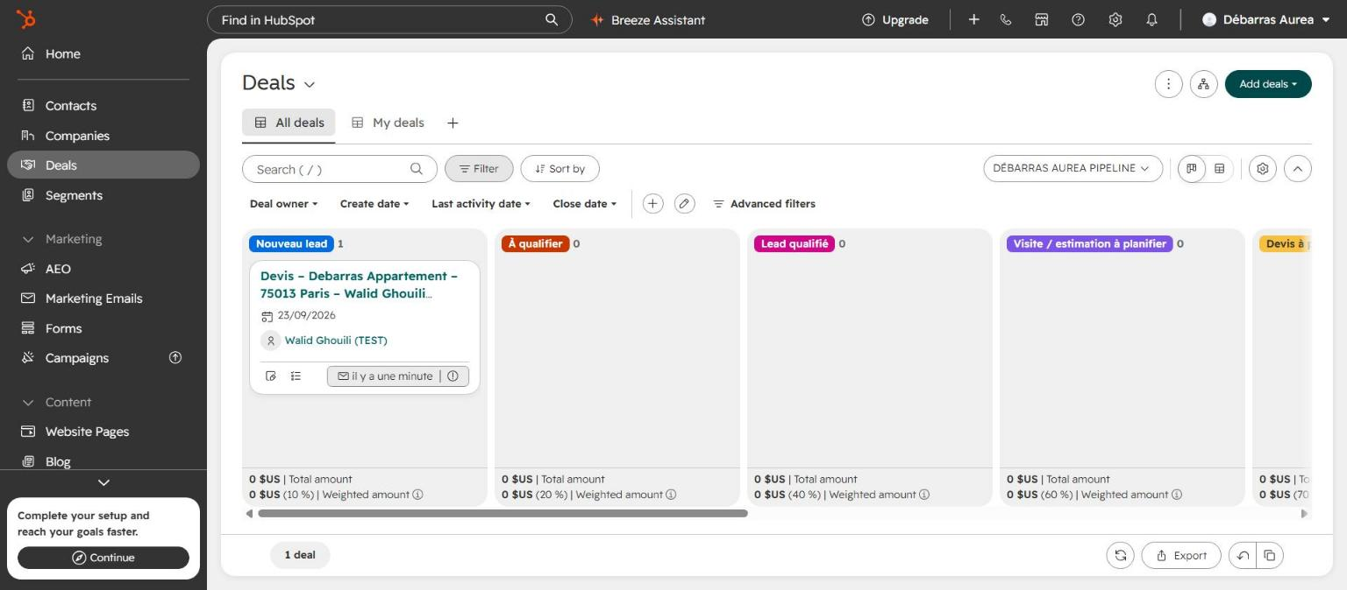
Deals board – the test quote in “Nouveau lead”
Tip: add the filter “Create date = Today” or sort by Create date to see only today’s requests.

2. Find a person – Contacts
Contacts → All contacts → search by name, email or phone. New website contacts get Lead status “New”; lifecycle moves to “Opportunity” automatically once a deal is attached.
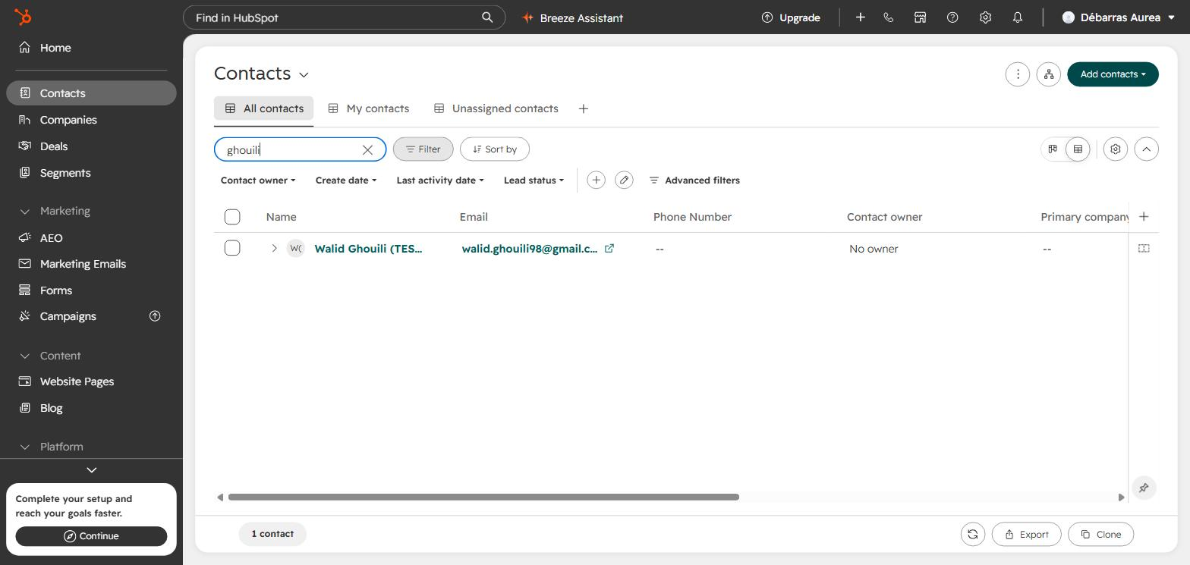
Contacts list filtered on “ghouili”

3. The contact record
Click the name to open the record. Left: phone, city, lifecycle, lead status. Right: the associated deal (click it to open the deal). Middle: AI summary and history.
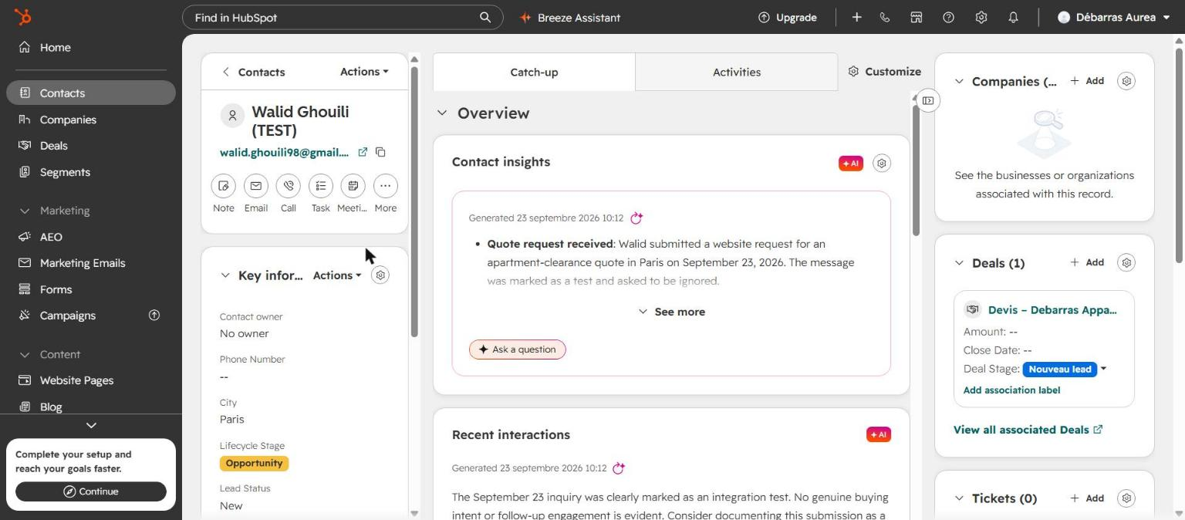
Contact record – deal card on the right, stage “Nouveau lead”

4. Full request details – the Note
Activities → Notes. Each submission adds a note “Demande de devis (site web)” (or “Message de contact”) with service, location, phone, email, consent, extra answers (timing, floor, surface…) and the message. The same text is also in the deal description.
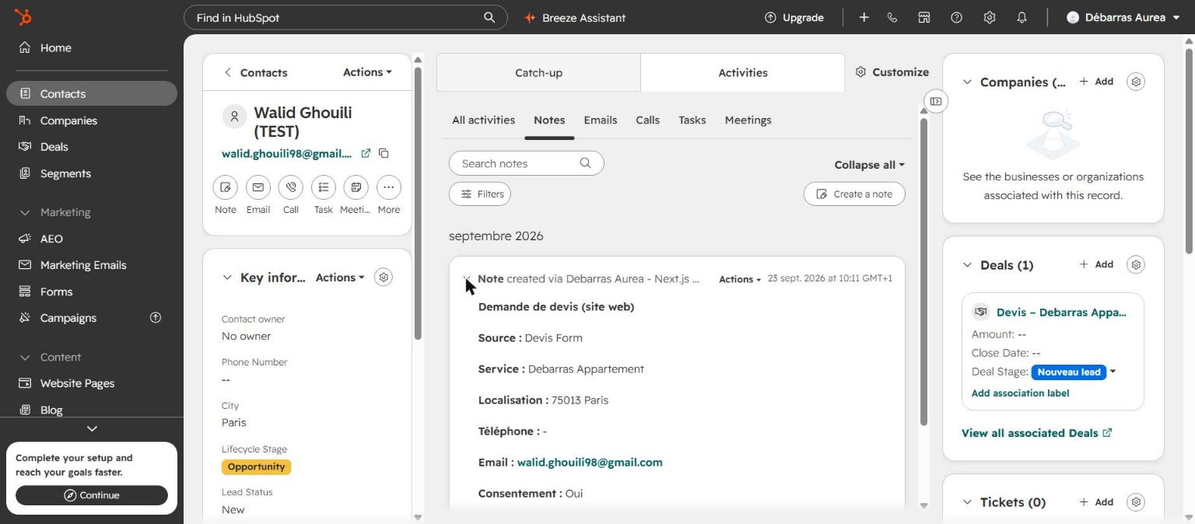
Note created by the integration with all form fields
The notification email sent to contact@debarras-aurea.fr also appears under Activities → Emails, because the inbox is connected to HubSpot.
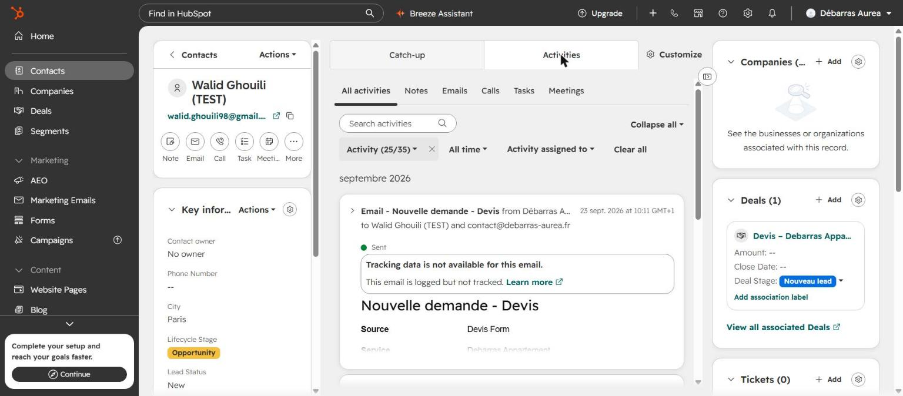
Activities – the logged notification email

5. Technical check – is the integration working?
Development → Monitoring → Logs (or Keys → Service Keys → “Debarras Aurea – Next.js CRM Integration” → View Logs). One submission = 4 calls: search, contacts, deals, notes. Green 200/201 = OK. A red 401 means the token was rotated/revoked (update the HUBSPOT_ACCESS_TOKEN secret in GitHub and redeploy); 400 on /deals usually means a pipeline stage was changed.
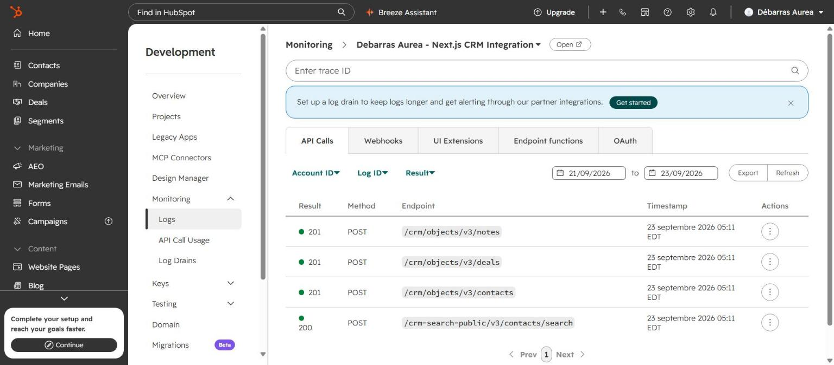
API call logs for the test – all 4 calls succeeded

If a lead is on the site but not in HubSpot
- Nothing is lost: leads still arrive by email – HubSpot errors never block the form.
- HubSpot side: check the logs above for red lines.
- Server side: on the VPS, run pm2 logs debarras and look for lines starting with [HubSpot].
- “sync skipped” in the logs: the HubSpot key was not deployed. Check the HUBSPOT_ACCESS_TOKEN secret in the GitHub “deploy” environment.

Clean-up
Delete the test records when done: open the deal “Devis – Debarras Appartement – 75013 Paris – Walid Ghouili (TEST)” → Actions → Delete, then the contact “Walid Ghouili (TEST)”.

